**ITALY DIABETES CARE DEVICES MARKET**

According to Intelli, the Italy diabetes care devices market was valued at USD 1,193.3 million in 2024 and is projected to reach USD 1919.09 million by 2032, growing at a CAGR of 7.02% from 2024 to 2032.

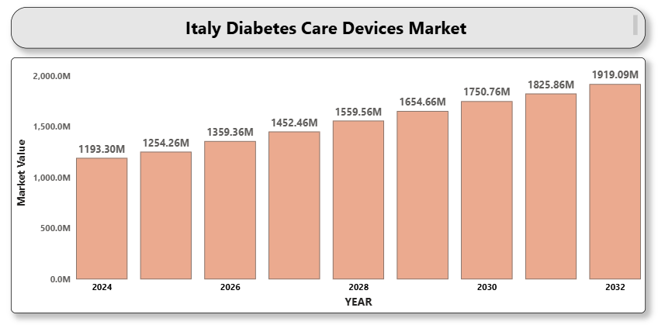

The market growth is primarily driven by the increasing prevalence of diabetes, growing awareness of diabetes management, and the adoption of advanced glucose monitoring technologies. Rising obesity rates, sedentary lifestyles, and an aging population are contributing to the growing incidence of diabetes in Italy. Innovations in wearable and minimally invasive devices are enhancing the patient experience and promoting regular monitoring. In addition, favorable reimbursement policies, public health initiatives to raise awareness about diabetes, and improved access to diagnostics are supporting market expansion. The rise of digital health platforms and smartphone integration with glucose monitors is also improving diabetes self-management.

**ITALY DIABETES CARE DEVICES MARKET DEFINITION**

Diabetes care devices are tools used to monitor and manage blood glucose levels in individuals with diabetes. These include blood glucose meters, continuous glucose monitoring (CGM) systems, insulin delivery devices such as insulin pens and pumps, and other accessories. These devices are essential in both type 1 and type 2 diabetes management to ensure proper glycemic control and prevent complications. In Italy, advancements in sensor technologies, mobile connectivity, and personalized health solutions are transforming diabetes care. The growing demand for less invasive and more efficient monitoring solutions is accelerating the development and adoption of modern diabetes care devices.

**ITALY DIABETES CARE DEVICES MARKET OVERVIEW**

The Italy diabetes care devices market is experiencing steady growth due to technological innovation, increased patient awareness, and healthcare system improvements. Remote patient monitoring, integration with digital platforms, and the shift toward home-based care are reshaping diabetes management in the country. Supportive regulatory frameworks and healthcare provider collaboration are facilitating the use of continuous glucose monitoring and smart insulin delivery systems. However, high costs of advanced devices and disparities in access to healthcare in certain regions may limit market growth. Despite these challenges, the trend toward preventive healthcare and government support for chronic disease management is expected to provide lucrative opportunities.

**ITALY DIABETES CARE DEVICES MARKET SEGMENT ANALYSIS**

**By Product Type**

• Blood Glucose Monitoring Devices: Includes blood glucose meters, test strips, and lancets.

• Continuous Glucose Monitoring (CGM) Systems: Includes sensors, transmitters, and receivers.

• Insulin Delivery Devices: Includes insulin pens, insulin pumps, and jet injectors.

• Others: Includes diabetes management apps, smart insulin patches, and implantable sensors.

**By End User**

• Hospitals & Clinics: Primary healthcare providers for diabetes diagnosis and treatment.

• Homecare Settings: Rising due to remote monitoring, telemedicine, and personalized diabetes care.

• Diagnostic Centers: Specialized in diabetes screening and long-term glucose tracking.

**By Distribution Channel**

• Retail Pharmacies: Widely accessible point of purchase for diabetes care products.

• Online Pharmacies: Rapidly growing due to convenience, discounts, and digital health integration.

• Hospital Pharmacies: Serve inpatient and outpatient diabetes management needs.

**ITALY DIABETES CARE DEVICES MARKET COMPETITIVE LANDSCAPE**

The Italy diabetes care devices market is competitive, with global and regional players actively investing in product innovation and market expansion. Key strategies include strategic partnerships with healthcare institutions, continuous product enhancements, and portfolio diversification. Competition is intense in the CGM and insulin delivery segments due to rapid technological advances and the need for user-friendly, integrated solutions.

**KEY PROFILES OF ITALY DIABETES CARE DEVICES MARKET**

• Abbott Laboratories

• Medtronic plc

• Dexcom, Inc.

• F. Hoffmann-La Roche Ltd

• Ascensia Diabetes Care Holdings AG

• Novo Nordisk A/S

• Sanofi S.A.

• Ypsomed Holding AG

• Insulet Corporation

• Becton, Dickinson and Company

**KEY DEVELOPMENTS**

* **In February 2025**, Dexcom announced the launch of its continuous glucose monitoring (CGM) technology in Italy, set to begin in March. As part of this expansion, the company ended its distribution agreement with Roche to establish a direct presence in the Italian market.
* **A close-up of hands holding a tablet and a pen

  Description automatically generatedIn 2024**, At the 17th International Conference on Advanced Technologies and Treatments for Diabetes (ATTD) in Florence, Italy, Roche presented recent accuracy data for its new Accu-Chek SmartGuide solution for real-time continuous glucose monitoring (rtCGM).
* **On March 26, 2025**, Italy launched new screening programs for early detection of type 1 diabetes in children and teenagers, in collaboration with the IHI EDENT1FI project, marking a significant step in preventive healthcare efforts. This initiative aims to identify the condition at an early stage and improve long-term health outcomes.

**MARKET ATTRACTIVENESS**

The Italy diabetes care devices market offers attractive opportunities driven by an increasing diabetic population, supportive healthcare policies, technological innovation, and the shift toward digital and home-based care.

**PORTER’S FIVE FORCES ANALYSIS**

• Threat of New Entrants: Moderate — Requires high R&D and regulatory compliance.

• Bargaining Power of Suppliers: Low to Moderate — Multiple suppliers reduce dependency.

• Bargaining Power of Buyers: High — Patients demand cost-effective, convenient solutions.

• Threat of Substitutes: Low — Limited alternatives to advanced monitoring technologies.

• Competitive Rivalry: High — Driven by innovation and market expansion efforts.

**TABLE OF CONTENTS**

1. **INTRODUCTION OF ITALY DIABETES CARE DEVICES MARKET**

1.2 Scope of Report

1.3 Assumptions

1. **EXECUTIVE SUMMARY**
2. **RESEARCH METHODOLOGY**

3.1 Data Mining

3.2 Validation

3.3 Primary Interviews

3.4 List of Data Sources

1. **ITALY DIABETES CARE DEVICES MARKET OUTLOOK**

4.1 Overview

4.2 Market Dynamics

4.2.1 Drivers

4.2.2 Restraints

4.2.3 Opportunities

4.2.4 Trends

4.3 Porter’s Five Forces Model

4.4 Value Chain Analysis

1. **ITALY DIABETES CARE DEVICES MARKET, BY PRODUCT TYPE**

5.1 Blood Glucose Monitoring Devices

5.2 Continuous Glucose Monitoring (CGM) Systems

5.3 Insulin Delivery Devices

5.4 Others

1. **ITALY DIABETES CARE DEVICES MARKET, BY END USER**

6.1 Hospitals & Clinics

6.2 Homecare Settings

6.3 Diagnostic Centers

1. **ITALY DIABETES CARE DEVICES MARKET, BY DISTRIBUTION CHANNEL**

7.1 Retail Pharmacies

7.2 Online Pharmacies

7.3 Hospital Pharmacies

1. **ITALY DIABETES CARE DEVICES MARKET COMPETITIVE LANDSCAPE**

8.1 Overview

8.2 Company Market Ranking

8.3 Key Development Strategies

1. **COMPANY PROFILES**

**9.1 Abbott Laboratories**  
9.1.1 Overview  
9.1.2 Financial Performance  
9.1.3 Product Outlook  
9.1.4 Key Developments

**9.2 Medtronic plc**  
9.2.1 Overview  
9.2.2 Financial Performance  
9.2.3 Product Outlook  
9.2.4 Key Developments

**9.3 Dexcom, Inc.**  
9.3.1 Overview  
9.3.2 Financial Performance  
9.3.3 Product Outlook  
9.3.4 Key Developments

**9.4 F. Hoffmann-La Roche Ltd**  
9.4.1 Overview  
9.4.2 Financial Performance  
9.4.3 Product Outlook  
9.4.4 Key Developments

**9.5 Ascensia Diabetes Care Holdings AG**  
9.5.1 Overview  
9.5.2 Financial Performance  
9.5.3 Product Outlook  
9.5.4 Key Developments

**9.6 Novo Nordisk A/S**  
9.6.1 Overview  
9.6.2 Financial Performance  
9.6.3 Product Outlook  
9.6.4 Key Developments

**9.7 Sanofi S.A.**  
9.7.1 Overview  
9.7.2 Financial Performance  
9.7.3 Product Outlook  
9.7.4 Key Developments

**9.8 Ypsomed Holding AG**  
9.8.1 Overview  
9.8.2 Financial Performance  
9.8.3 Product Outlook  
9.8.4 Key Developments

**9.9 Insulet Corporation**  
9.9.1 Overview  
9.9.2 Financial Performance  
9.9.3 Product Outlook  
9.9.4 Key Developments

**9.10 Becton, Dickinson and Company**  
9.10.1 Overview  
9.10.2 Financial Performance  
9.10.3 Product Outlook  
9.10.4 Key Developments

1. **KEY DEVELOPMENTS**

10.1 Product Launches/Developments

10.2 Mergers and Acquisitions

10.3 Business Expansions

1. **APPENDIX**

11.1 Related Research